AP Chemistry Summer Practice Problems

I. The metric system and conversions
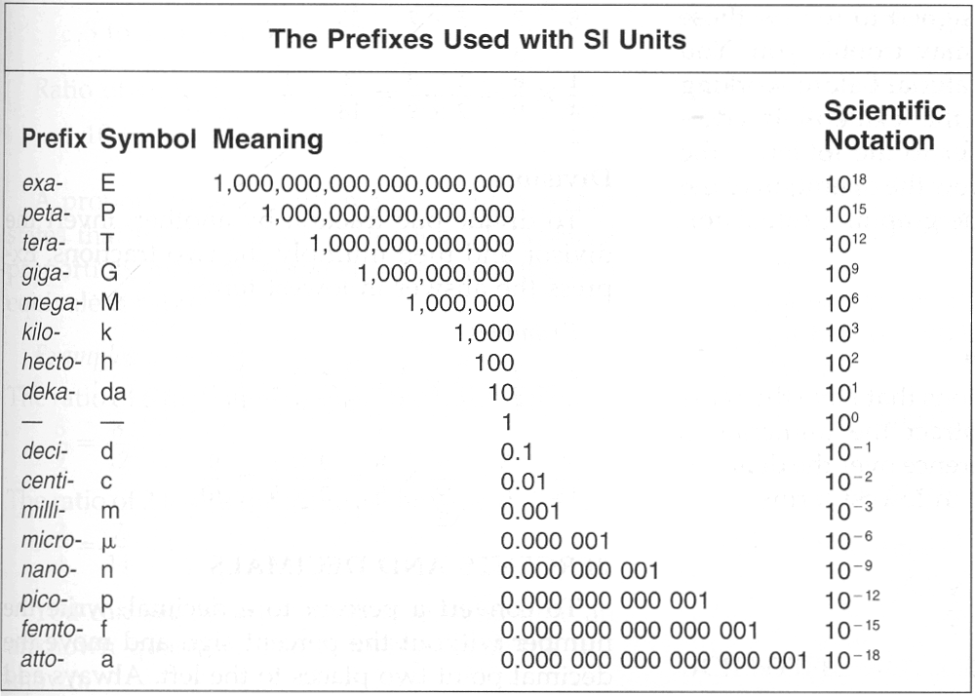
Use the conversion chart to make the following conversions:

1. 1000 cm to meters: 2. 453 mL to L:

3. 7.21 nm to km: 4. 7123 meters to mm:

5. 697 L to mL: 6. 0.00056 nm to m:

7. 47 pm to nm: 8. 39.39 m to micrometers:

II. Atomic Theory and Structure
A. For each of the following elements, list:
1. The name of the element
2. How many protons are contained within the nucleus?
3. How many neutrons are contained within the nucleus?
4. How many electrons are contained within a single neutral isotope of this element?

a. F – 19 b. Al – 26 c. Cr – 53

d. Ag – 111 e. N – 14 f. C – 14

g. U – 253 h. S – 32 i. Ar – 40

B. What is an isotope?

C. Chromium has four naturally occurring isotopes that are found at the following abundances:
Isotope | Abundance
Cr – 50 | 4.35%
Cr – 52 | 83.79%
Cr – 53 | 9.50%
Cr – 54 | 2.36%

Find the average atomic mass of chromium.

II. The Periodic Table
1. Which element from each set is most electronegative? (Circle)
a. F or C
b. Al or Cl
c. Po or S
d. Cs or I
e. Ca or Cl
f. N or S

2. Write the electron configuration for each of the following elements:
- Oxygen: ___________________________________
- Carbon: ___________________________________
- Chlorine: ___________________________________
- Krypton: ___________________________________
- Zinc: ___________________________________
- Palladium: ___________________________________
- Potassium: ___________________________________
- Lead: ___________________________________

3. Draw an orbital diagram for each of the following elements:
- Nitrogen b. Fluorine

c. Copper d. Tin

III. Stoichiometry
1. Find the molar mass (g/mol) of the following elements and compounds:
a. H₂ b. O₂ c. CO₂

d. C₆H₁₂O₆ e. CH₃OH f. HPO₄

2. Solve the following stoichiometry problems:

a. Find the mass (in grams) of 0.785 moles of NaOH.

b. How many carbon atoms are contained in 84.3 g of ethyne (C₂H₂)?

IV. Naming compounds (use the “stuff to memorize for the AP exam” chart for help)
Write the name for each of the following compounds, and label each as ionic (I) or covalent (C):

1. SCl₃ - 2. CO₂ - 3. H₂SO₄ –

4. CH₄ - 5. PF₄ - 6. Na₂O –

7. KSCN- 8. NaC₂H₃O₂ - 9. PbNO₂ –

10. NaClO (aka bleach) - 11. NH₄ClO₄ -

