Name: __________________________ Thermochemistry Worksheet #1
AP Chemistry

Section 1: Kinetic Molecular Theory and the Kelvin scale MONDAY

1. The freezing point of water at 1 atm pressure is _______ °C or ___________ K. (Ref: pg. 17)

2. Convert the following temperatures from Celsius to Kelvin, expressing each with the correct number of significant figures: (Ref: pg. 17)

a. 25.0 °C = __________ b. 100.0 °C = __________ c. 422.35 °C = __________

3. Convert the following temperatures from Kelvin to Celsius, expressing each with the correct number of significant figures: (Ref: pg. 17)

a. 300 K = __________ b. 250.00 K = __________ c. 567.21 K = _____________

4. What is the purpose of using the Kelvin scale in Chemistry?

5. What is “absolute zero” and how is it related to kinetic energy?

6. According to kinetic-molecular theory, if the temperature of a gas is raised from 100°C to 200°C, the average kinetic energy of the gas will __________.
A) double
B) increase by a factor of 1.27
C) increase by a factor of 100
D) decrease by half
E) decrease by a factor of 100

7. The Maxwell-Boltzmann distributions for two samples of a gas are shown below. One sample is at 20°C, and the other is at 120°C. Which one is which? Explain your answer.
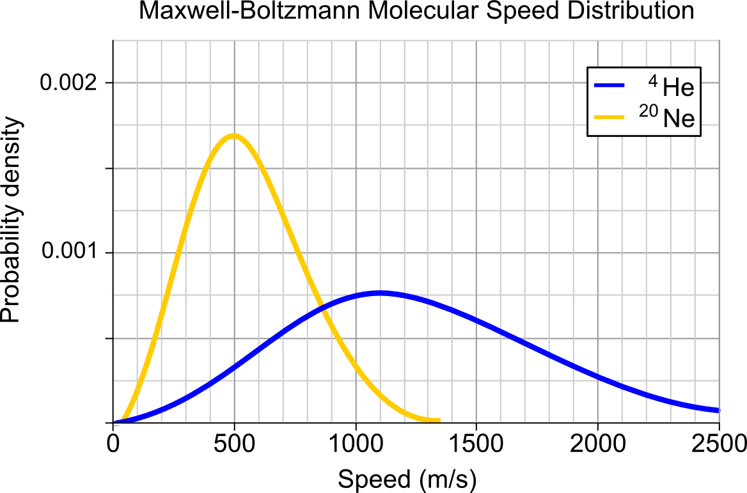
Section 2: Energy, Heat, and Calorimetry TUESDAY

8. Label each of the following as endothermic (EN) or exothermic (EX): (Ref: sec. 5.2)
a. ice melting _______
b. water freezing _______
c. boiling soup _______
d. Ammonium thiocyanate and barium hydroxide are mixed at 25°C: the temperature drops. ____
e. A chemical reaction inside a handwarmer causes it to feel warm. _______
f. Combustion of gasoline in a car engine. _______

9. For each situation above, show whether there is negative enthalpy change (–ΔH) or positive enthalpy change (+ΔH).

10. Explain the first law of thermodynamics in your own words.

11. What is heat capacity, and what are the units for heat capacity?

12. What is specific heat (aka specific heat capacity), and what are the units for specific heat?

13. A sample of calcium carbonate [CaCO3 (s)] absorbs 45.5 J of heat, upon which the temperature of the sample increases from 21.1 °C to 28.5 °C. If the specific heat of calcium carbonate is 0.82 J/g-K, what is the mass (in grams) of the sample?

14. The temperature of a 12.58 g sample of calcium carbonate [CaCO3 (s)] increases from 23.6 °C to 38.2 °C. If the specific heat of calcium carbonate is 0.82 J/g-K, how many joules of heat are absorbed?

15. An 8.29 g sample of calcium carbonate [CaCO3 (s)] absorbs 50.3 J of heat, upon which the temperature of the sample increases from 21.1 °C to 28.5 °C. What is the specific heat of calcium carbonate?

Section 3: Enthalpy THURSDAY

16. Write the name for each of the following processes, and give the definition for each process. These are listed in a chart pgs. 76 – 77 in your test prep book.

ΔH_{rxn}:

ΔH_{f}:

ΔH_{comb}:

ΔH_{sol}:

ΔH_{vap}:

ΔH_{fus}:

ΔH_{BDE}:

17. What does the ° symbol mean when it is attached to an enthalpy value? (Ex: ΔH°_{rxn}) Ref: pg. 183

18. The value of ΔH° for the reaction below is -72 kJ. Calculate how many kJ of heat are released when 80.9 grams of HBr is formed in this reaction. (Ref: pg. 174, sample exercise 5.4)

H2 (g) + Br2 (g) → 2HBr (g)

19. The value of ΔH° for the reaction below is -126 kJ. Calculate how many kJ of heat are released when 2.00 mol of NaOH is formed in the reaction. (Ref: pg. 174, sample exercise 5.4)

2 Na2O2 (s) + 2 H2O (l) → 4NaOH (s) + O2 (g)

20. The value of ΔH° for the reaction below is +128.1 kJ. How many kJ of heat are consumed when 5.10 g of CO (g) is formed as shown in the equation? (Ref: pg. 174, sample exercise 5.4)

CH3OH (l) → CO (g) + 2 H2 (g)

21. Explain Hess’s Law in your own words.

22. Given the following reactions, calculate the enthalpy of the reaction of Fe₂O₃ and CO.
(Ref: pgs. 181-182)
Fe2O3 (s) + 3CO (s) → 2Fe (s) + 3CO2 (g) ΔH = -28.0 kJ
3Fe (s) + 4CO2 (s) → 4CO (g) + Fe3O4 (s) ΔH = +12.5 kJ
3 Fe2O3 (s) + CO (g) → CO2 (g) + 2 Fe3O4 (s) ΔH = ???

23. Given the following reactions, calculate the enthalpy of the reaction of N₂ and O₂ to produce nitric oxide. (Ref: pgs. 181-182)
N2 (g) + 2 O2 (g) → 2NO2 (g) ΔH = 66.4 kJ
2NO (g) + O2 (g) → 2NO2 (g) ΔH = -114.2 kJ
N2 (g) + O2 (g) → 2NO (g) ΔH = ???

24. Consider the following two reactions:

A → 2B ΔH°rxn = 456.7 kJ/mol
A → C ΔH°rxn = -22.1kJ/mol

Determine the enthalpy change for the process: 2B → C (Ref: pg. 187, sample 5.12)

25. Given the data in the table below, calculate ΔH°rxn for the reaction: (Ref: pg. 187, sample 5.11)
Ca(OH)2 + 2 H3AsO4 → Ca(H2AsO4)2 + 2 H2O

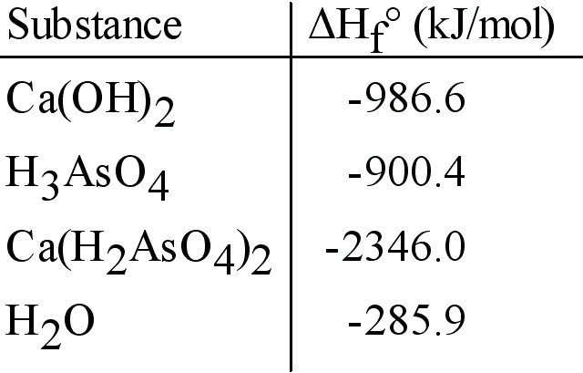

26. Given the data in the table below, calculate ΔH°rxn for the reaction: (Ref: pg. 187, sample 5.11)
3 Cl2 (g) + PH3 (g) → PCl3 (g) + 3 HCl (g)

