AP Unit 6 Jeopardy Questions and Study Guide

Important equations and things to remember:
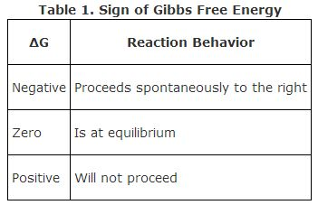
q = mcΔT
ΔG = ΔH – TΔS
ΔH = ΣH_{f} products – ΣH_{f} reactants
ΔS = ΣS_{f} products – ΣS_{f} reactants

Predicting spontaneity: Reactions are spontaneous when ΔS_{universe} is positive, or more specifically, when ΔG is negative.

Enthalpy: (answer key at the end of the document)

100: What is the symbol for change in enthalpy?

200: Which of the following is an endothermic process?
- Ice melting
- Water freezing
- HCl and BaOH are mixed and react, causing a drop in temperature
- Condensation of water vapor

300: The temperature of a 35.2 g sample of iron increases from 23.7 °C to 29.5 °C. If the specific heat of iron is 0.450 J/g-K, how many joules of heat are absorbed?

400: The value of ΔH° for the reaction below is -126 kJ. __________ kj are released when 2.00 mol of NaOH is formed in the reaction?
2 Na₂O₂ (s) + 2 H₂O (l) → 4NaOH (s) + O₂ (g

500: Given the following reactions,
CaCO3 (s) → CaO (s) + CO2 (g) ΔH = 178.1 kJ
C (s, graphite) + O2 (g) → CO2 (g) ΔH = -393.5 kJ
the enthalpy of the reaction
CaCO3 (s) → CaO (s) + C (s, graphite) + O2 (g)
is __________ kJ.
Section 2: Entropy and Gibbs free energy
100: What does it mean to say a reaction or process is “spontaneous”?
200: Which one of the following is always positive when a spontaneous process occurs?
A) ΔSsystem
B) ΔSsurroundings
C) ΔSuniverse
D) ΔHuniverse
E) ΔHsurroundings
300: For the reaction below, ΔH° is -125 kJ/mol and ΔS° is +253 J/K ∙ mol. This reaction is:
2C₄H₁₀ (g) + 13O₂ (g) → 8CO₂ (g) + 10H₂O (g)
A) spontaneous at all temperatures
B) spontaneous only at high temperature
C) spontaneous only at low temperature
D) nonspontaneous at all temperatures
E) unable to determine without more information

400: For a reaction to be spontaneous under standard conditions at all temperatures, the signs of ΔH° and ΔS° must be __________ and __________, respectively.
A) +, +
B) +, -
C) -, +
D) -, -
E) +, 0

500: Given the following table of thermodynamic data, the vaporization of TiCl₄ is:
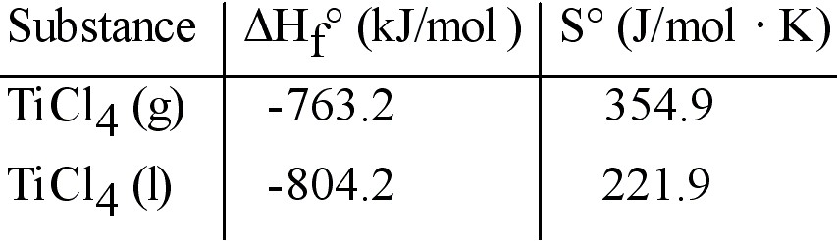

A) spontaneous at all temperatures
B) spontaneous at low temperature and nonspontaneous at high temperature
C) nonspontaneous at low temperature and spontaneous at high temperature
D) nonspontaneous at all temperatures
E) not enough information given to draw a conclusion

JEOPARDY ANSWERS:

ENTHALPY:
100: ΔH
200: A. Ice melting is the correct answer. Ice must take in energy to melt, so it is endothermic.
300: 92 J. Use q = mcΔT to solve this problem. m = mass, c = specific heat, ΔT = change in temp.
400: 63 kJ are released
500: 571.6 kJ

ENTROPY:

100: Spontaneous means something occurs without outside intervention (in other words, a reaction or process that happens on its own). Any reaction/process that requires adding heat, electricity, or energy in ANY form is NOT spontaneous.

200: C. The entropy of the universe must be positive in order for a reaction to be spontaneous.

300: A is the correct answer.

Justification: Reactions are spontaneous when ΔG is negative. Using the equation ΔG = ΔH – TΔS, we can predict the sign of ΔG if we know values for ΔH and ΔS. (See table below)

ΔH | ΔS | ΔG
+ | + | Depends on temperature (high temps are spontaneous, low temps are not)
– | – | Depends on temperature  (low temps are spontaneous, high temps are not)
– | + | –
+ | – | +

400: C (see justification above)

500: C
ΔH = ΣH_{f} products – ΣH_{f} reactants, so ΔH = (-763.2) – (-804.2) = 41 kJ/mol
ΔS = ΣS_{f} products – ΣS_{f} reactants, so ΔS = (354.9) – (221.9) = 133 kJ/mol
Since both ΔH and ΔS are both positive, spontaneity depends on temperature. The process would be nonspontaneous at low temperatures and spontaneous at high temperatures (see chart above)

