Unit 5 Guide: Liquids and Solutions
January 7th – January 24th (14 days)
AP Chemistry

Week 1 objectives Reading (for homework): Chapter 11 in B&L (pgs. 425 – 452)
By the end of week 1, you will be able to….
- Identify five types of intermolecular forces: dispersion forces, dipole-dipole forces, hydrogen bonds, and ion-dipole forces) (section 11.2, pgs. 428 – 436)
Explain each of the four forces here:
Dispersion forces: ___________________________________________
Dipole-dipole forces: ___________________________________________
Hydrogen bonds: ___________________________________________
Ion-dipole forces: ___________________________________________
Ionic bonds: ___________________________________________
- Rank intermolecular forces by strength (see above)

- Compare and contrast intermolecular forces with Van der Waals forces:
What do intermolecular forces have in common?

What makes a Van der Waals force different from other intermolecular forces?

- Understand and be able to describe the following properties of liquids:
Viscosity (pg. 437): ____________________________________________________
What affects viscosity? How can you know whether or not a liquid will be viscous?

Surface tension (pg. 437): ________________________________________________
What affects surface tension? How can you predict whether a liquid will have high or low surface tension?

Volatility (pg. 443): ____________________________________________________
What affects volatility? How can you know whether or not a liquid will be volatile?

- Explain the meaning of the term “vapor pressure”
Vapor pressure is…

- Explain how vapor pressure is a type of dynamic equilibrium.
Dynamic equilibrium is:

How is vapor pressure a type of dynamic equilibrium?

- Be able to explain the relationship between vapor pressure and boiling point.
As vapor pressure increases, boiling point __________________.

- Draw diagrams of intermolecular forces using Lewis dot diagrams and dotted lines

Week 2: Properties of Solutions
By the end of week 2, you will be able to…
- Explain how intermolecular forces relate to: boiling point, freezing point, solubility. (11.3 – 11.4)

- Use knowledge of intermolecular forces to predict the relative boiling points, freezing points, or solubility of different compounds. (11.3 – 11.4)

- Predict the relative boiling points of different substances based on intermolecular forces. (LAB)
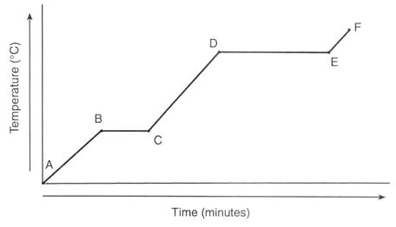
- Interpret a heating curve for a substance. (see diagram)
Label the heating curve to the right with the following terms: melting, vaporization, ice, liquid water, steam, melting point, boiling point

- Explain how each of the following is related to phase changes:
Heat of fusion/enthalpy of fusion (ΔH_{fus}):

Heat of vaporization/enthalpy of vaporization (ΔH_{vap}):

Heat of sublimation/enthalpy of sublimation (ΔH_{sub}):

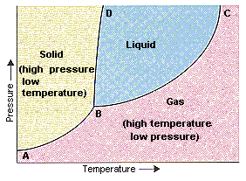
- Be able to interpret a phase diagram (pgs. 445 – 448, see right)

Label the phase diagram with the triple point, and show where the substance would become a supercritical fluid.

- Interpret a phase diagram for a given substance. (11.6)

Assigned reading and problems from Brown and Lemay:
Chapter 8, all sections (pgs. 289 – 320)
Problems: 8.1 – 8.13 odds, 8.17, 8.21, 8.23, 8.24, 8.25, 8.31, 8.33, 8.34, 8.41, 8.45, 8.47, 8.51, 8.53, 8.57, 8.58
Chapter 9, all sections* (pgs. 331 – 372)
*NOTE: we will BRIEFLY cover these topics. Use the problems to review, but you do not have to know this chapter in detail.
Problems: 9.11, 9.13, 9.19, 9.21, 9.25, 9.29, 9.30, 9.31, 9.47, 9.51, 9.55, 9.63, 9.67
Chapter 11, sections 11.1 – 11.4, 11.6 (pgs. 425 – 442, 445 – 448)
Problems: 11.9, 11.11, 11.12, 11.15, 11.16, 11.19, 11.20, 11.21, 11.23, 11.25, 11.37, 11.57, 11.61, 11.62
Chapter 12, sections 12.1 – 12.8 (pgs. 463 – 496)
Problems: 12.43, 12.47, 12.49, 12.63, 12.65

Labs:

Week 1: Thin Layer Chromatography Lab
Description: You will use your knowledge of polarity and intermolecular forces to design an experiment to identify an unknown painkiller using Thin Layer Chromatography (TLC).

Phase changes and Intermolecular Forces lab
Description: You will compare the relative boiling points of different compounds, and rank them by the strength of their intermolecular forces.

